**DAILY ONLINE ACTIVITIES SUMMARY**

|  |  |  |  |  |  |  |  |  |
| --- | --- | --- | --- | --- | --- | --- | --- | --- |
| **Date:** | **13/06/2020** | | | | | **Name:** | **V ANJANA PAI** | |
| **Sem & Sec** | **IV sem & B section** | | | | | **USN:** | **4AL18CS094** | |
| **Online Test Summary** | | | | | | | | |
| **Subject** | | **DATA COMMUNICATION** | | | | | | |
| **Max. Marks** | | **30** | | **Score** | | | **25** | |
| **Certification Course Summary** | | | | | | | | |
| **Course** | **Introduction to Ethical Hacking** | | | | | | | |
| **Certificate Provider** | | | **Greatlearning academy** | | **Duration** | | | **4.0 hours** |
| **Coding Challenges** | | | | | | | | |
| **Problem Statement1: Write a C Program to calculate Electricity Bill.**  **Problem Statement2: Write a Java Program to find the first non repeated character of a given string.** | | | | | | | | |
| **Status: Executed** | | | | | | | | |
| **Uploaded the report in Github** | | | | | **YES** | | | |
| **If yes Repository name** | | | | | **lockdown-coding** | | | |
| **Uploaded the report in slack** | | | | | **YES** | | | |

Online Test Summary: 18CS46 test was scheduled from 2:00pm to 2:30pm. The portion for the IA was 1st and 2nd module there were 30 questions and the time assigned was 30 minutes the questions were mcq type.

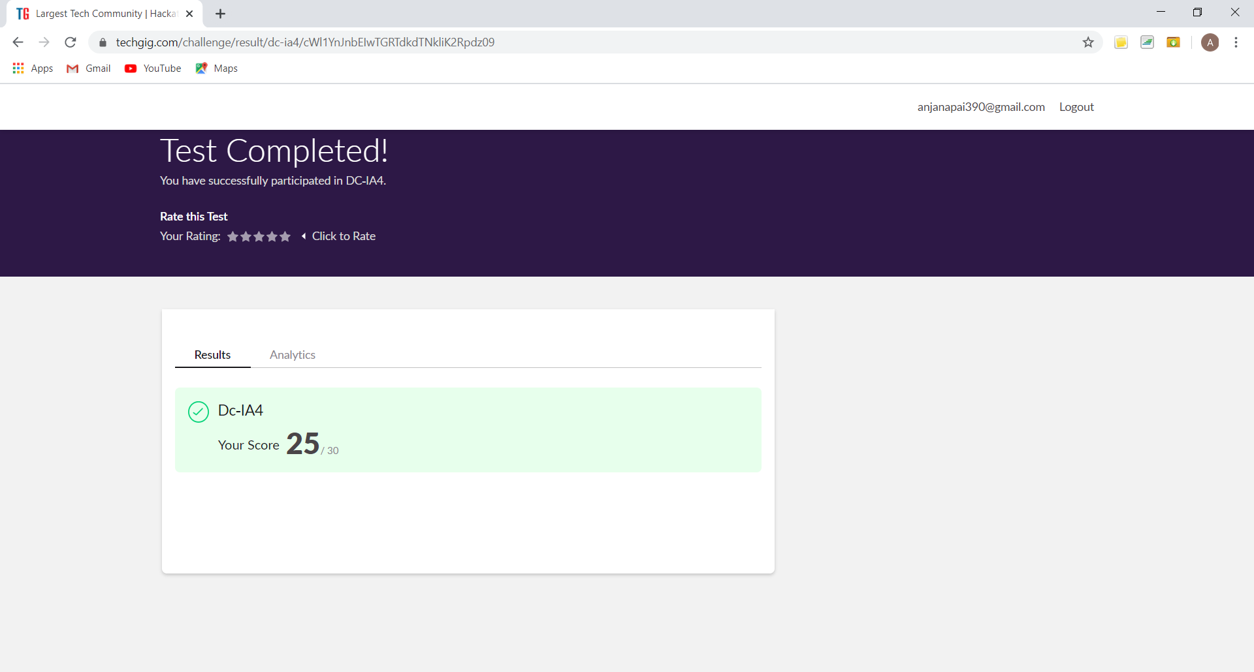

This is the snap shot of completion of test and the marks obtained in 18CS46.

Online Certification Course Summary: Today I enrolled for Introduction to Ethical Hacking course from Great Learning Academy. I learnt about the Career and Growth Ladder in Ethical Hacking and also about the Domains and Process Implementation under Ethical Hacking.

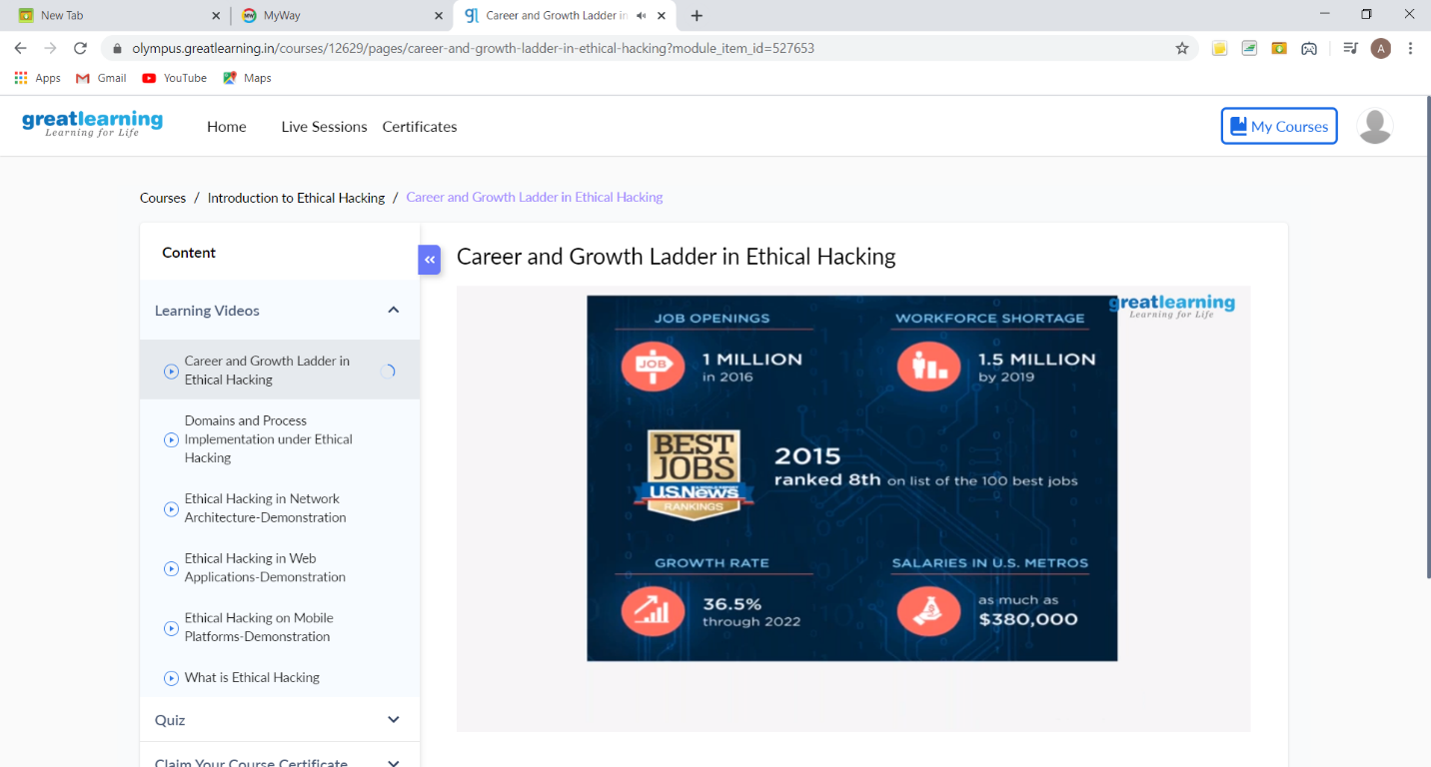

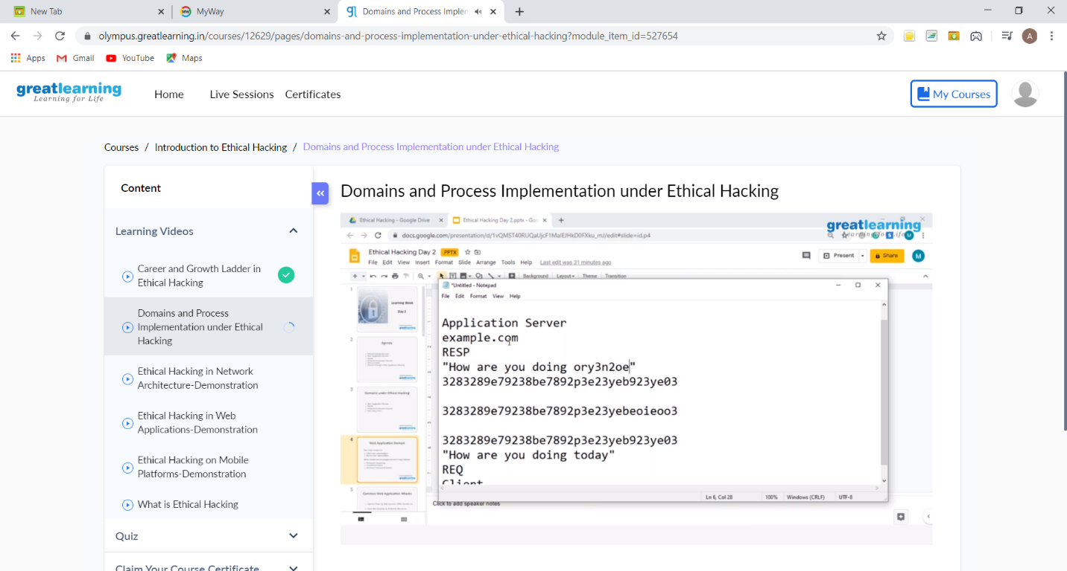

These are the Snap shots of today’s sessions.

Online Coding Summary: **Today I had received one program from prof. Venkatesh CSE Dept and another from prof. Vasudev CSE Dept. The programs are mentioned above in the coding challenges(pg.01). I have also uploaded it to my Github repository.**

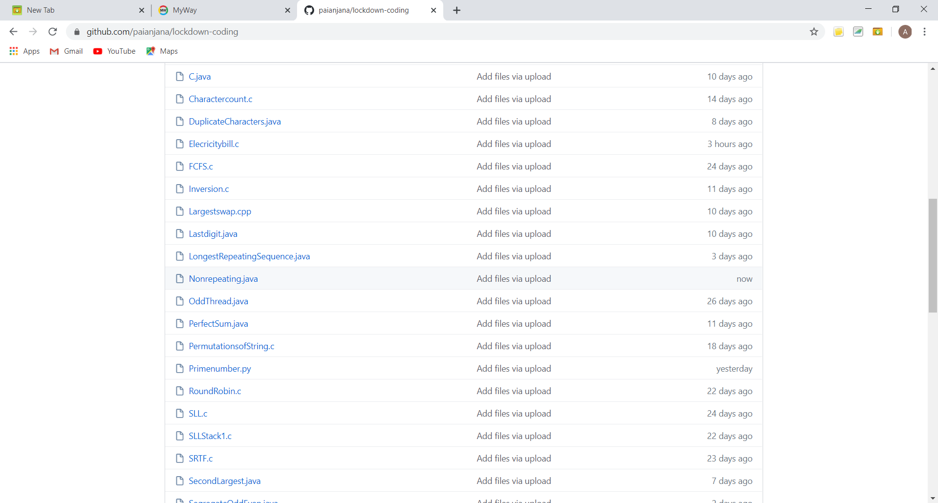

It is the snap shot of my repository where I have uploaded the code. File name is Electricitybill.c and leaders in Nonrepeating.java